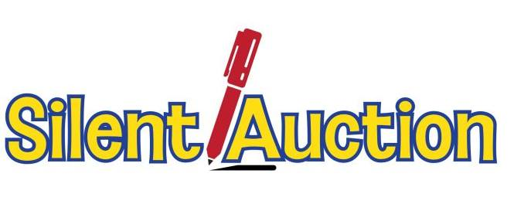
Saturday, May 5th
6:00 – 10:00 pm
Makom Shalom’s 1st ever silent auction, fundraiser and party!

899 S. Plymouth Court (9th & State Street)

Enjoy tasty food and bid on some great deals!
Be the highest bidder at this silent auction to benefit Makom Shalom
There is something for everyone to enjoy!

Classes: Running, dancing, cooking, weight loss, mindfulness, LinkedIn, Aleph classes, public speaking
Consults: gardening, new business, nutrition, interior decorating, professional organizing
Services: coaching, Reiki sessions, catering, child care, editing/proofreading, pet care
Theatre tickets or attend theatre with theatre critic
Books: Young adult books and books written by members
Artwork, photography, jewelry, greeting and gift cards
Aleph baseball caps and yamulke’s from Central Asia
Restaurants, Hair Salons, Health Club
Event space at Beit Yichud

Please bring your credit card, check book, or cash and
a few friends to support Makom Shalom!

Parking: Street parking pay boxes on Michigan Ave, Wabash, State Street, etc. Parking lots: $12 behind Dearborn Station on 8th Street. Or use 2 lots on North and South corners of 8th and State Streets for $13-17. OR Use Spothero.com to find $8 and $10 parking at the same lots. See Page 2 for a map of garages found through Spothero.com.

Public Transportation: Brown, Green, Purple, Pink, Red, Blue and Orange lines all within 2-3 blocks. Bus # 146, 29, 62 all stop at corner, and #22, as well as dozens other buses within 2 blocks.

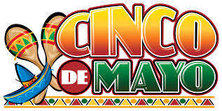
Pot luck food suggestions: Let Linda Touchstone (handman4906@aol.com) know food you can contribute. For Cinco de Mayo, we’ll have some Mexican food along with whatever you want to share!

RSVP: Jaqi.makomshalom@gmail.com for questions

