7 Steps to Set Up Your Facebook Fundraiser
Have a special birthday, anniversary? Whatever you are celebrating, you can ask your Facebook friends to support your favorite synagogue in your name! You’ll be amazed! When people care about you, they care about what you care about! Follow these instructions to tell the world why you love Makom and get started!
Step 1: Go to your profile page. Click Create, then click Fundraiser.
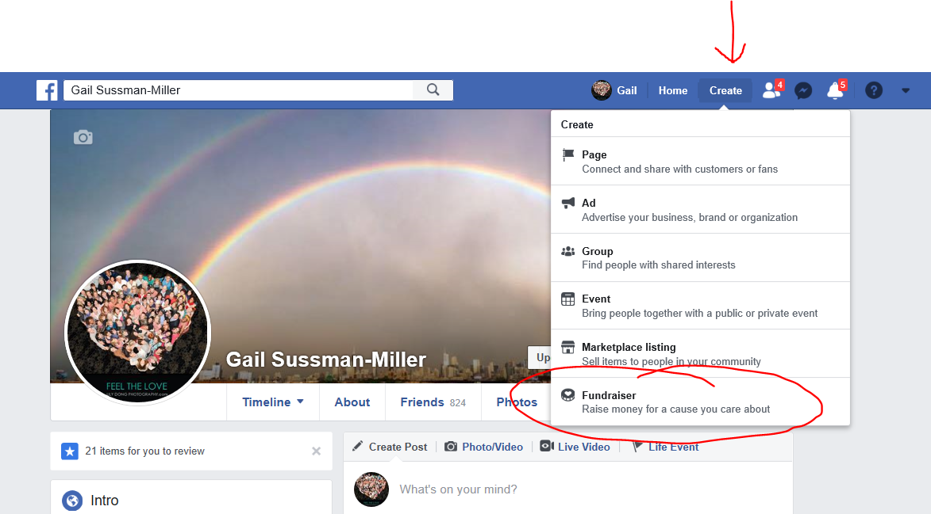

Step 2: Click Nonprofit Step 3: Search for our Makom Shalom
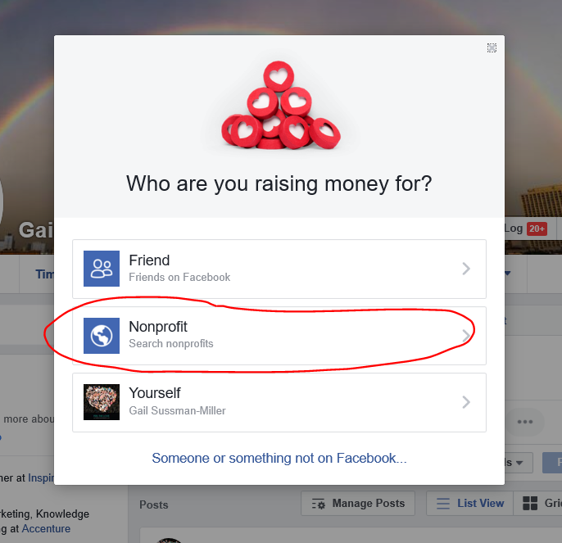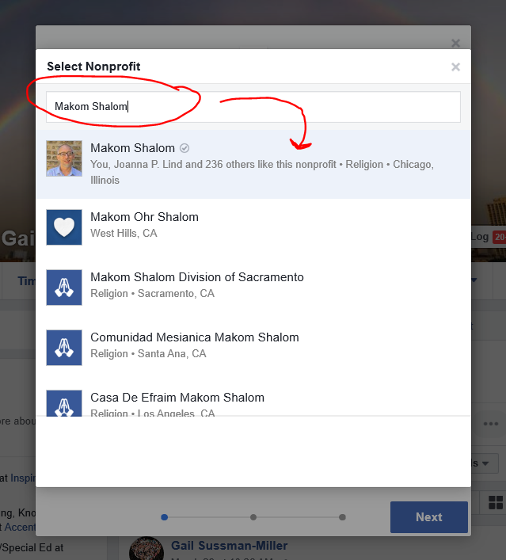
Step 4: Enter info. Click Next. Step 5: See tip below to enter text
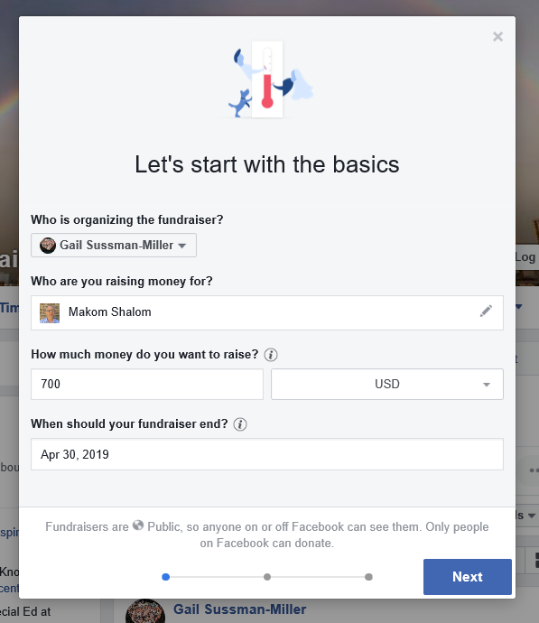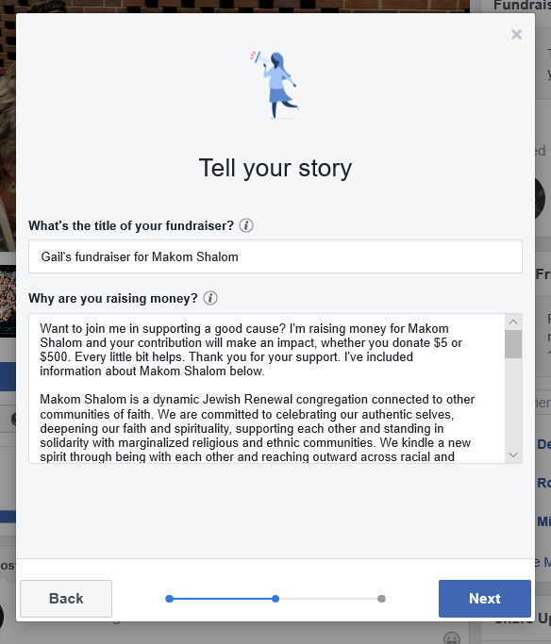

TIP: Type your message about your fundraiser in Microsoft Word or another software first because Facebook’s editing features are poor. Then copy and paste your text here.
Step 6: Keep/change suggested photo Step 7: Donate 1st to motivate others!